Types of Words

🧠 What Are the Types of Words in Linguistics?
# Source: AI Source: Provided by: [Data Path: Persons Table -> ID Column: 1, Name_En Column: Motasem Essam] -> From: [Chatgpt (GPT-4-turbo)] on [7/24/2025]
In linguistics, types of words refer to the categories or classes that words belong to based on their function and meaning in a sentence. These are also called parts of speech.

✳️ Main Types of Words (Parts of Speech)
# Source: AI Source: Provided by: [Data Path: Persons Table -> ID Column: 1, Name_En Column: Motasem Essam] -> From: [Chatgpt (GPT-4-turbo)] on [7/24/2025]
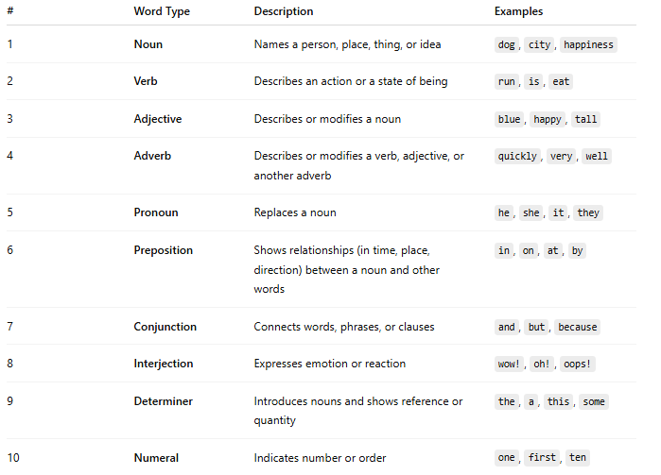

# | Word Type | Description | Examples
1 | Noun | Names a person, place, thing, or idea | dog, city, happiness
2 | Verb | Describes an action or a state of being | run, is, eat
3 | Adjective | Describes or modifies a noun | blue, happy, tall
4 | Adverb | Describes or modifies a verb, adjective, or another adverb | quickly, very, well
5 | Pronoun | Replaces a noun | he, she, it, they
6 | Preposition | Shows relationships (in time, place, direction) between a noun and other words | in, on, at, by
7 | Conjunction | Connects words, phrases, or clauses | and, but, because
8 | Interjection | Expresses emotion or reaction | wow!, oh!, oops!
9 | Determiner | Introduces nouns and shows reference or quantity | the, a, this, some
10 | Numeral | Indicates number or order | one, first, ten

🧩 Other Word Classifications
# Source: AI Source: Provided by: [Data Path: Persons Table -> ID Column: 1, Name_En Column: Motasem Essam] -> From: [Chatgpt (GPT-4-turbo)] on [7/24/2025]
Besides parts of speech, words can also be categorized by their structure or origin:

By Structure:
# Source: AI Source: Provided by: [Data Path: Persons Table -> ID Column: 1, Name_En Column: Motasem Essam] -> From: [Chatgpt (GPT-4-turbo)] on [7/24/2025]
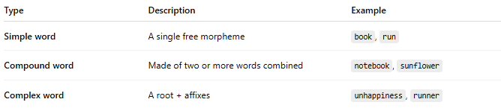
Type | Description | Example
Simple word | A single free morpheme | book, run
Compound word | Made of two or more words combined | notebook, sunflower
Complex word | A root + affixes | unhappiness, runner

By Function:
# Source: AI Source: Provided by: [Data Path: Persons Table -> ID Column: 1, Name_En Column: Motasem Essam] -> From: [Chatgpt (GPT-4-turbo)] on [7/24/2025]
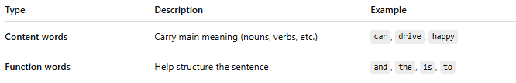
Type | Description | Example
Content words | Carry main meaning (nouns, verbs, etc.) | car, drive, happy
Function words | Help structure the sentence | and, the, is, to

✅ Summary:
# Source: AI Source: Provided by: [Data Path: Persons Table -> ID Column: 1, Name_En Column: Motasem Essam] -> From: [Chatgpt (GPT-4-turbo)] on [7/24/2025]
There are many types of words, but the most important division is between the parts of speech, which define how a word functions in a sentence (noun, verb, adjective, etc.).

